Resume
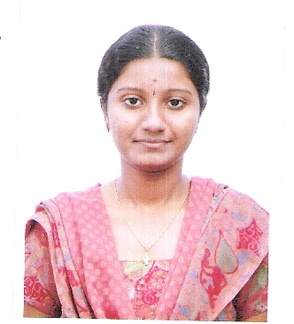

G.S.Shruti Amrithaa
No 1023/12b,
Society colony,
Checkpost,
Oddanchantram Mobile no : 9962525197
Email ID : shrutiamrithaa@yahoo.com

Career Objective
To seek a challenging position for constant learning and updating my knowledge to contribute my abilities for the development of the organization.
Academic Profile
COURSE | SCHOOL/COLLEGE | Board/  UNIVERSITY | YEAR OF  PASSING | PERCENTAGE OF MARKS
MBA-IT | Avinashilingam school of management technology,Cbe. | Avinashilingam  university | 2012 | 75
B.C.A | Stella Maris College  Chennai | Madras University | 2010 | 65
XII-STANDARD | Shri Natesan Vidhyala school,Tambaram | State board | 2007 | 80
X-STANDARD | Shri Natesan Vidhyala school,Tambaram | Matriculation | 2005 | 60

Technical Skill

Programming Languages : C, Html, Lotus notes ,VB and Dot Net
Databases : SQL
Operating Systems : Windows 98/XP/7
Experience
Keymind learning India private ltd- Three months experience from May 2012 to July 2012 as Customer Delight Executive.

Area of interest
- Marketing.
- Web designing.
Project
- Online Job Search with Lotus Notes and Dot Net.
- Summer Project on “Corporate Social Responsibility” at Rane TRW Steering system Ltd, Chennai.
- Tanning in Rane TRW Steering System Ltd, Chennai for a period of 2 days and gained knowledge about the Production process.
- Major Project on “The Study of Consumer Behavior Towards Idhayam oil” at V.V.V & Sons Edible Oil Ltd, Virudhunagar.
Extra-Curricular Activities
- An active Volunteer in various functions of schools and colleges.
- Member of the National service scheme, Stella Maris College.
- Attended an industrial visit to A1 Chips in Coimbatore.
.
Personal Profile

Father’s Name : P.Gunasekaran
Mother’s Name : G.Sahunthala
Date of Birth : 16-11-1989
Age : 22
Gender : Female
Nationality : Indian
Languages Known : Tamil, English (to speak & write)
Hobbies : Cooking and Drawing

Declaration

I hereby declare that the information furnished above is true to the best of my knowledge.

Place: Chennai
Date: 12-09-2012 ( G.S.Shruti Amrithaa)

